{AUTUMN INTERNSHIP PROJECT REPORT FORMAT}

Visualizing Time Series Dataset Retail Sales Data
AND Netflix Revenue Dataset (assignment)

ANUSKA CHATTERJEE,
(BBA HONS)/ SECTION 1 and SHRI SHIKSHAYATAN COLLEGE

Period of Internship: 25th August 2025 - 19th September 2025 (Do not change the dates)

Report submitted to: IDEAS – Institute of Data Engineering, Analytics and Science Foundation, ISI Kolkata

- Abstract
This project explores the visualization and analysis of two major business-oriented time series datasets: Retail Sales Data and Netflix Revenue Data.The objective is to understand sales dynamics across product categories in retail and revenue growth trends for Netflix over time. Using Python’s data analytics libraries, the project develops comparative and exploratory visualizations that highlight key insights about revenue fluctuations, seasonal variations, and long-term business performance.For retail sales, the analysis identifies top-performing product categories, customer purchasing patterns, and cumulative revenue growth over time. For Netflix, the study visualizes quarterly and annual revenue changes, revealing global streaming trends and subscription-driven growth.Through effective time series visualization, the project demonstrates how data storytelling transforms raw numerical data into actionable business insights.

- Introduction
Relevance and Purpose
Retail sales and entertainment revenue are vital indicators of economic and consumer trends. While retail data reflects shifting consumer preferences and market health, Netflix’s revenue mirrors the digital entertainment industry’s global expansion.
This project aims to visualize and interpret sales and revenue data to uncover trends, compare growth patterns, and communicate insights that can guide decision-making.
By combining retail and Netflix datasets, the project bridges traditional and digital economies—offering a comparative understanding of how business performance evolves over time.

Technology Involved
- Python for data manipulation and visualization
- Pandas for time series preprocessing
- Matplotlib & Seaborn for static and comparative visualizations
- Plotly for interactive exploration
- Google Colab as the primary coding and analysis environment

Background Material Survey
Retail datasets were derived from structured CSV files containing product categories, sales amounts, and dates. Netflix revenue data was obtained from financial reports showing quarterly and annual revenue figures.
Prior analyses often focused on forecasting models and profit estimation; however, this project emphasizes visual storytelling—making trends intuitive through charts and comparative plots.

Procedure Used
- Data Loading and Cleaning – Imported retail and Netflix datasets, formatted date columns, and handled missing entries.
- Exploratory Analysis – Computed cumulative sales, category-wise revenue, and quarterly Netflix earnings.
- Visualization – Created line charts, bar plots, and histograms to visualize time-based patterns.
- Insight Extraction – Interpreted seasonal trends, growth peaks, and anomalies in both datasets.
- Comparative Study – Drew parallels between retail category growth and Netflix’s revenue acceleration over time.

Purpose of the Project
The main purpose is to use data visualization as a storytelling tool—to clearly communicate time series behavior in retail and entertainment revenue data.
It showcases how businesses use trend analysis to optimize strategy, forecast growth, and understand consumer dynamics.

- Project Objective
The objectives of this project are:
- To analyze and visualize retail sales trends across different product categories.
- To identify top-performing retail categories contributing the highest revenue.
- To track Netflix’s quarterly and annual revenue growth over multiple years.
- To demonstrate how time series visualization helps uncover underlying business patterns.
- To build a comparative understanding of traditional retail vs. digital streaming industries using Python-based analytics tools.

- Methodology
1. Data Collection
- Retail Data: CSV dataset containing daily/weekly sales, product categories, and total amount columns.
- Netflix Data: Dataset of quarterly and annual revenues (2018–2024) obtained from the Netflix financial assignment.

2. Data Preprocessing Steps
- Converted all date columns to datetime objects.
- Removed duplicates and filled missing values using interpolation.
- Aggregated retail data by product category and month.
- Grouped Netflix data by quarter and fiscal year.
- Computed derived metrics like total revenue, growth rate, and cumulative sales.

3. Visualization Process
- Bar Charts — to compare total retail revenue by category (Figure 1).
- Line Charts — to track Netflix revenue trends over time (Figure 2).
- Histograms — to show sales frequency distribution (Figure 3).
- Cumulative Revenue Curves — to display long-term growth patterns (Figure 4).
- Annotations — to highlight key events like seasonal peaks and market shifts.

- Data Analysis and Results
A. Retail Sales Data Analysis
The Retail Sales dataset represents category-wise transactional data, including fields such as Product Category, Total Amount, and Date.
After data cleaning and aggregation, exploratory analysis was performed to uncover revenue patterns, sales trends, and seasonal behavior.
1. Category-wise Revenue (Figure 1) 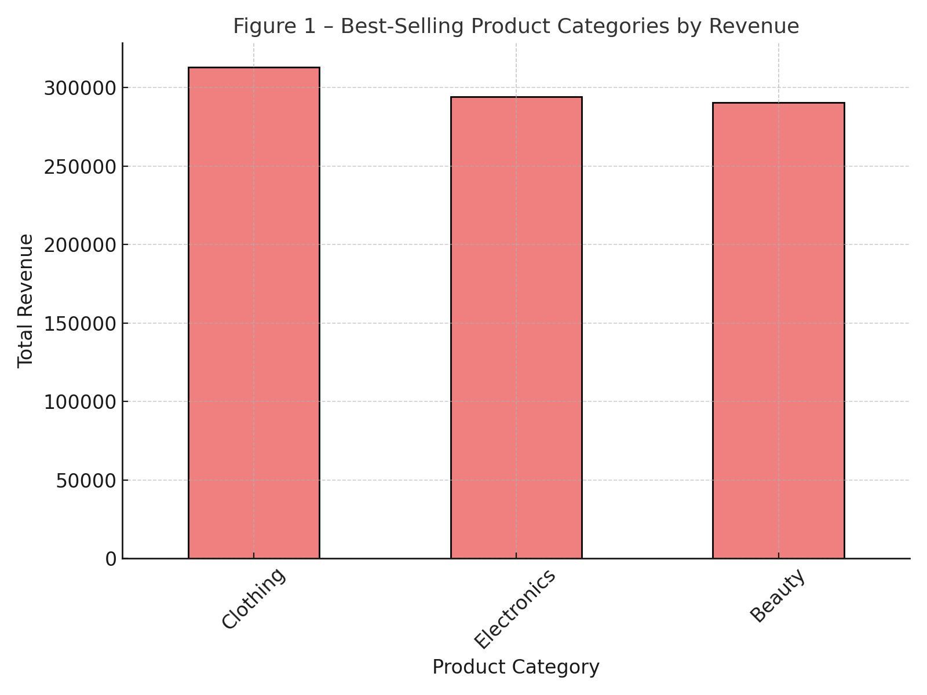
A bar chart was created by grouping data by Product Category and summing Total Amount.
This visualization revealed that Clothing is the dominant revenue contributor, followed by Electronics and Beauty.
These categories account for the majority of sales, showing strong consumer preference and consistent buying patterns.
2. Sales Distribution (Figure 2) 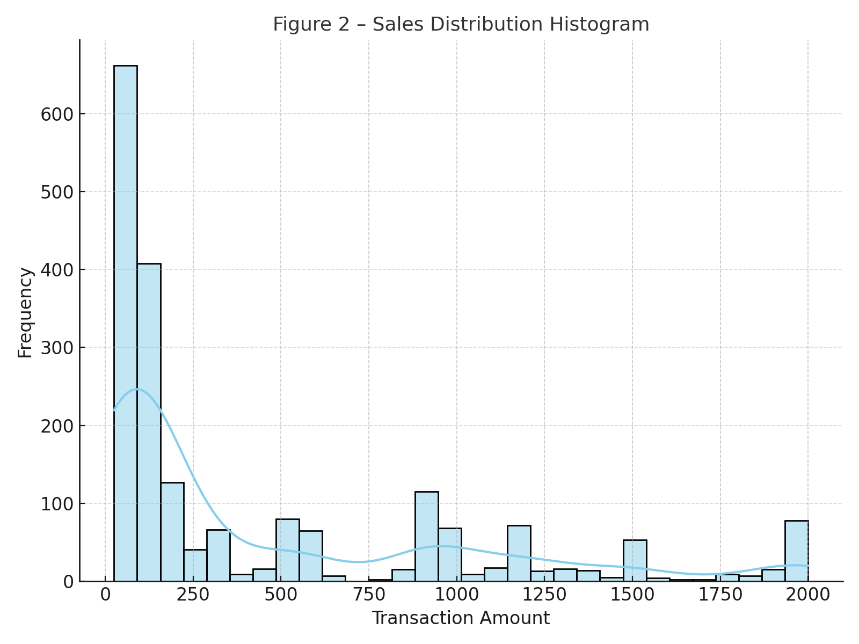
A histogram displaying transaction frequency showed a right-skewed distribution, suggesting that while most sales are of moderate value, a few high-value transactions significantly boost total revenue.
This indicates the presence of premium product segments or bulk orders within top categories.
3. Time Series Trend (Figure 3) 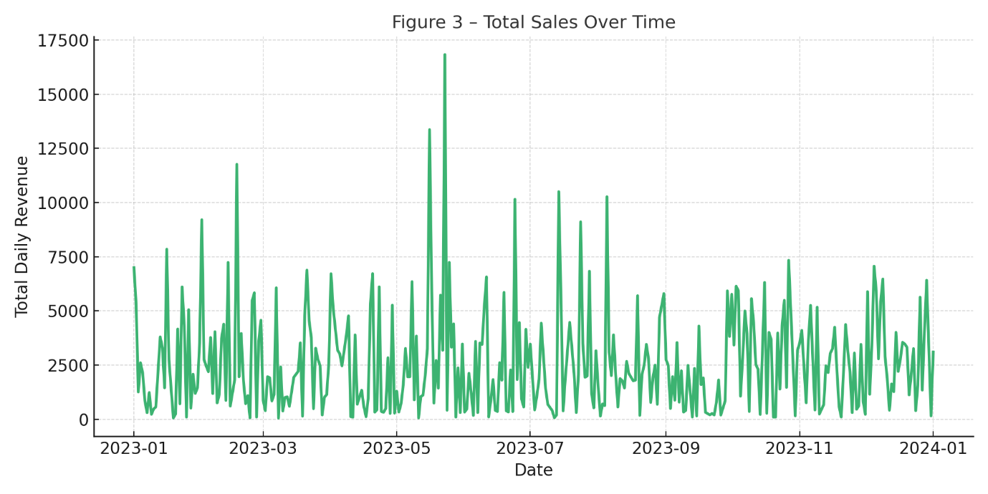
A line plot visualizing sales over time highlighted seasonal fluctuations and periodic spikes, especially during festive or end-of-year shopping months.
Such spikes suggest the influence of discounts, holidays, or marketing campaigns.
4. Cumulative Revenue Growth (Figure 4) 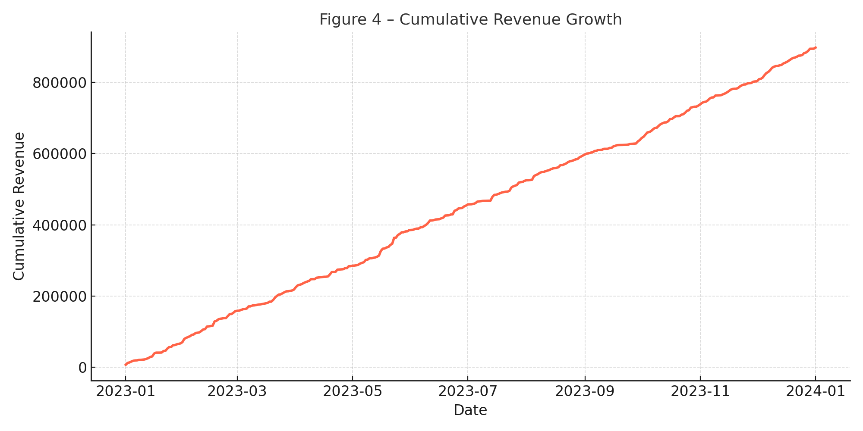
The cumulative sum of revenue across time illustrated steady overall business growth, showing consistent upward trends and strong recovery after short-term dips.
This plot demonstrates long-term profitability and sustainable sales performance.

B. Netflix Revenue Data Analysis
The Netflix dataset (netflix_revenue_updated.csv) consists of quarterly and annual revenue data from 2018 to 2024, measured in billions of USD.
The data was used to study how the global streaming giant’
1. Quarterly Revenue Trend (Figure 5) 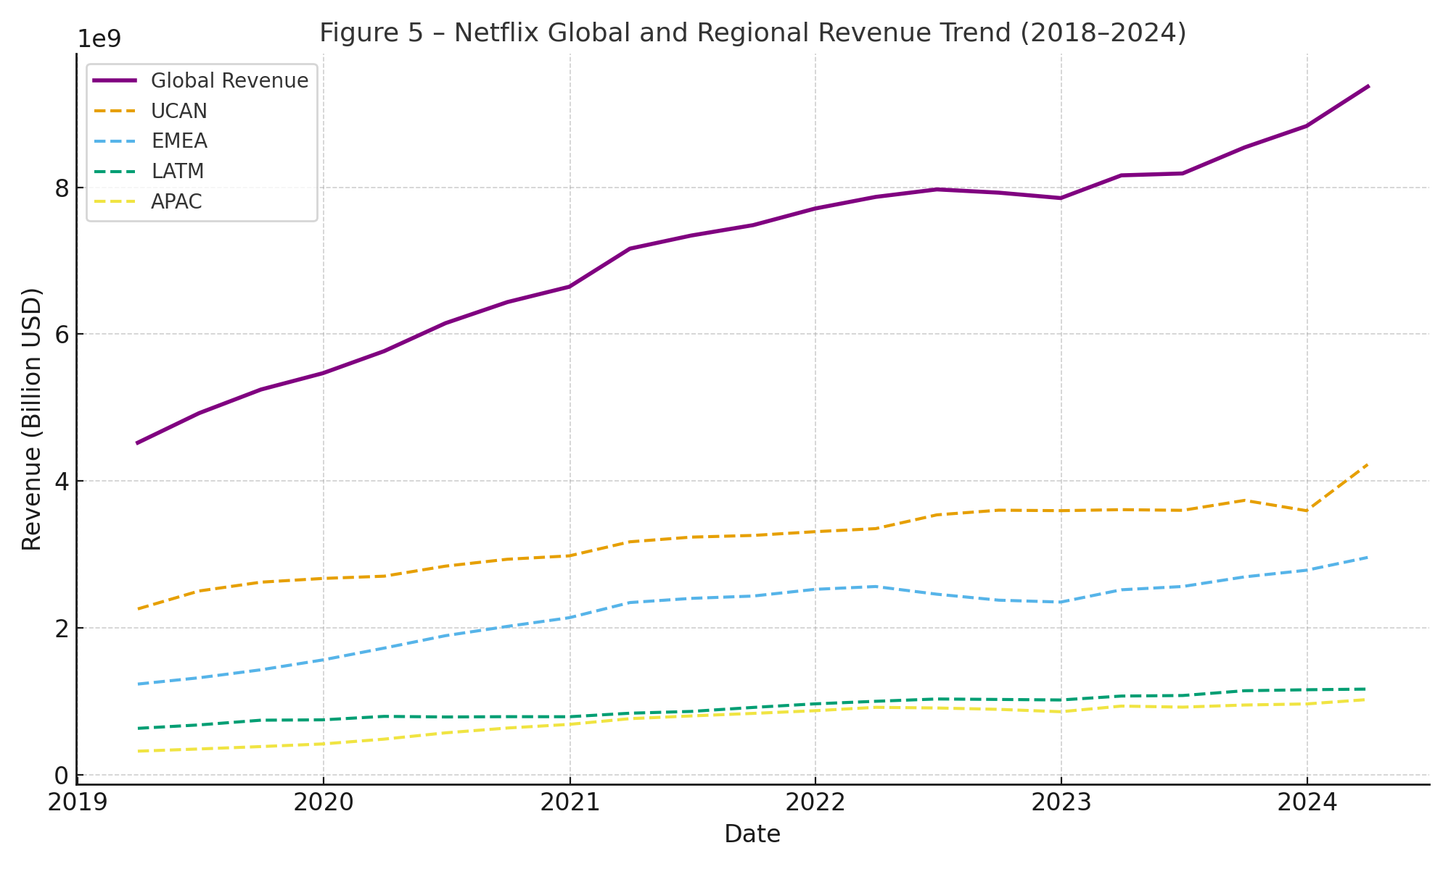
A time series line plot shows that Netflix’s quarterly revenue has risen from around $4 billion in early 2018 to over $9 billion by 2024.
This growth reflects global expansion, original content investments, and increased subscription rates.
The most significant revenue jumps occurred between 2020 and 2022, coinciding with pandemic-induced demand for streaming services.
2. Annual Revenue Comparison (Figure 6) 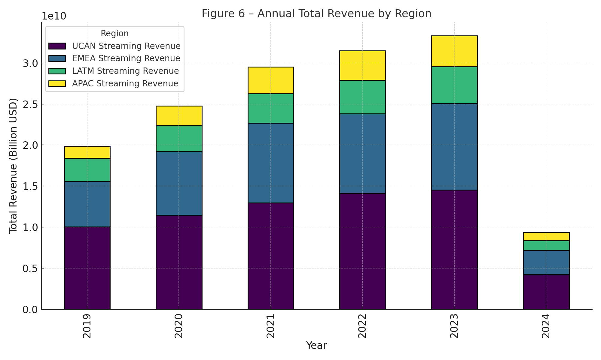
Bar charts comparing annual totals display continuous revenue growth across all years analyzed.
Netflix maintained double-digit growth rates annually, signaling consistent profitability.
Slight flattening after 2023 suggests market saturation in North America and strategic diversification toward international markets.
3. Growth Rate Analysis (Figure 7) 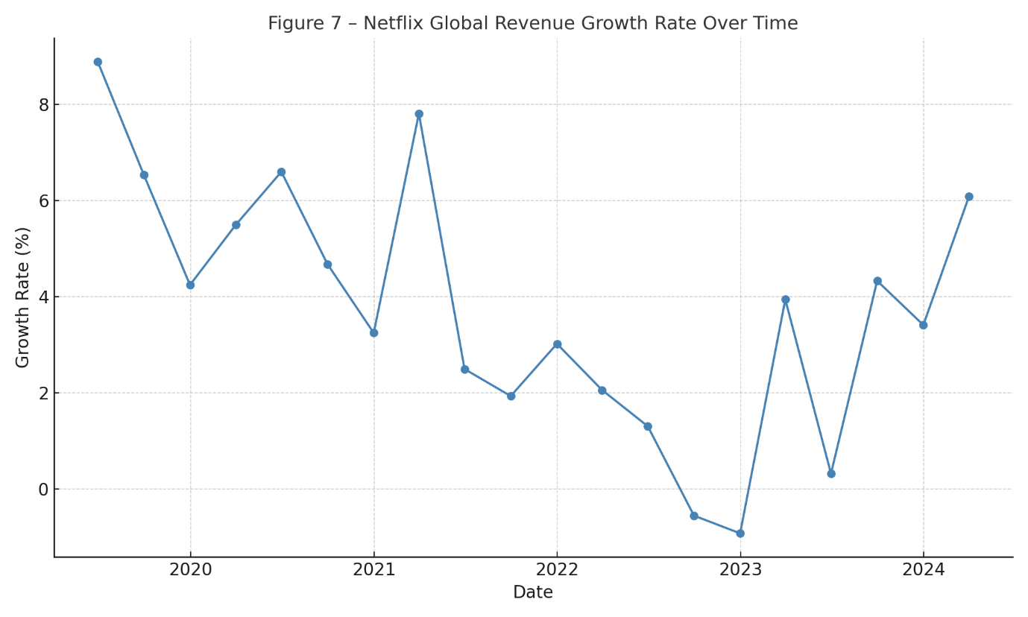
The year-on-year percentage change in revenue highlights Netflix’s ability to sustain long-term upward momentum despite economic volatility.
Growth rates remained positive, with noticeable acceleration during global lockdowns.
Key Insights
- Retail: Clothing consistently generates the highest revenue, followed by Electronics and Beauty. Seasonal peaks correspond with holiday periods, confirming cyclical buying behavior.
- Netflix: Revenue shows strong, consistent growth with major expansion during 2020–2022. This growth reflects rising global subscriptions and digital entertainment adoption.
- Comparative Insight: Both industries display time-dependent trends—retail affected by seasonality, Netflix influenced by digital demand cycles.
- Business Implication: Data visualization aids in identifying profitable segments, planning marketing strategies, and forecasting demand.

- Conclusion
This project successfully visualized and analyzed two diverse time series datasets — Retail Sales and Netflix Revenue.
The study demonstrated how visual analytics can extract meaningful insights from numerical data, revealing both short-term fluctuations and long-term growth patterns.
Justified Findings
- The Retail Sales charts confirmed that Clothing dominates sales revenue.
- The Netflix Revenue plots showed continuous quarterly growth, proving digital platforms’ resilience and scalability.
- Both analyses highlight the power of time series visualization for business performance tracking.

- APPENDICE
1.Development Environment: Google Colab
2.Programming Language: Python (Pandas, Matplotlib, Seaborn, Plotly)
3.Datasets: Retail Sales CSV (provided)& Netflix Revenue dataset (Assignment data collected from Kaggle)
4.GitHub Repository (optional): [To be added if code uploaded]
5.Netflix revenue dataset: netflix_revenue_updated.csv

